A Project Report On
“ E – Commerce platform for Luxury Warches ”
Royal Crown
Kamani Science Collage & Prtaprai Arts College Amreli

Developed By
Kureshi Mahmadsagil Y.
(Enr No – 24CS002UG02929)

Guided By
Mr. Nilesh Parghi

Year Of Submission
Submitted in partial fulfillment of the requirement for
the award of the degree of Bachelor of Computer
Application (BCA)

2026-2027


Saurashtra University - Rajkot
INDEX
No | Title | Page No
1 | Preface
2 | Acknowledgement
3 | Abstract
4 | Introduction
5 | Time Line Chart
6 | Project Profile
7 | Hardware Requirement
8 | Software Requirement
9 | Requirement Specification
10 | Problem Definition
11 | Project Planning& Scheduling
12 | System Analysis
13 | Feasibility Study
14 | Project Page Structure
15 | Data Dictionary
16 | Data Flow Diagram
17 | Context & First Level Diagram
18 | ER Diagram
19 | Use case Diagram
20 | Activity Diagram
21 | Screenshot (Page UI)
22 | Future Scope & References

PREFACE

The “E – Commerce Platform for Luxury Watches” project is developed as part of the BCA Semester 5 Project for the academic year 2026–2027 at Kamani Science College & Prataprai Arts College, Amreli, affiliated with Saurashtra University, Rajkot.

This project is developed by Kureshi Mahmadsagil Y. under the guidance of Mr. Nilesh Parghi. The main aim of this project is to create a simple and user-friendly online shopping platform where customers can easily browse products, view product details, add items to their cart, and place orders.

Working on this project gave me a practical understanding of web development, database management, user login, product management, shopping cart, and order processing. It also helped me understand how the concepts learned during the BCA course can be used to build a real-world application.

I am sincerely thankful to Mr. Nilesh Parghi, my project guide, for his valuable guidance, support, and suggestions throughout the project. I am also thankful to Kamani Science College & Prataprai Arts College, Amreli, and all the faculty members for their support and encouragement.

Finally, I would like to thank my friends, family, teachers, and everyone who supported me during the development and completion of this project.

ACKNOWLEDGEMENT

I would like to express my sincere gratitude to all those who have supported and guided me in the successful completion of my project entitled “E – Commerce Platform for Luxury Watches”, developed as part of the BCA Semester 5 Project for the academic year 2026–2027.
First of all, I would like to express my deepest gratitude to Mr. Nilesh Parghi, my project guide, for his valuable guidance, encouragement, continuous support, and constructive suggestions throughout the development of this project. His knowledge and guidance helped me to complete this project successfully.
I am sincerely thankful to the Principal, faculty members, and staff of Kamani Science College & Prataprai Arts College, Amreli, for providing me with the necessary facilities, resources, and academic support required for completing this project.
I am also grateful to Saurashtra University, Rajkot, for providing the academic framework and opportunity to undertake this project as part of the Bachelor of Computer Application (BCA) degree.
I would also like to thank my teachers and classmates for their valuable suggestions, encouragement, and support during the development and testing of the system.
Finally, I am deeply thankful to my parents, family members, and friends for their constant encouragement, motivation, and support throughout my academic journey and during the completion of this project.
I sincerely thank everyone who contributed directly or indirectly to the successful completion of the “E – Commerce Platform for Luxury Watches” project.
Kureshi Mahmadsagil Y.

ABSTRACT

The “E – Commerce Platform for Luxury Watches” is a web-based application developed to make online shopping simple, convenient, and user-friendly. The system allows customers to create an account, browse different products, search for products, view product details, add items to a shopping cart, and place orders online.

The system also provides an effective way to manage products, customers, and orders. It reduces the need for manual shopping processes and helps users save time by providing shopping services from anywhere through the internet.

This project is developed as part of the BCA Semester 5 Project for the academic year 2026–2027 at Kamani Science College & Prataprai Arts College, Amreli, affiliated with Saurashtra University, Rajkot.

The development of this project provided practical knowledge of web development, database management, user authentication, product management, shopping cart functionality, and order processing. Overall, the system provides a simple and efficient platform for managing online shopping activities.

INTRODUCTION

The “E – Commerce Platform for Luxury Watches” is a web-based application developed to provide a simple, convenient, and user-friendly online shopping experience. The system allows customers to create an account, browse different luxury watches, search for products, view product details, add items to a shopping cart, and place orders online.
The frontend of the project is developed using HTML, CSS, and JavaScript to create an attractive and interactive user interface. EJS (Embedded JavaScript Templates) is used to display dynamic content and product information on web pages.
The backend is developed using Node.js and Express.js, which handle server-side operations, routing, user requests, product management, and order processing. MongoDB is used as the database to store and manage information such as users, products, categories, carts, and orders.
The system provides a smooth connection between the frontend, backend, and database. It reduces manual shopping processes and allows customers to manage their shopping activities easily through an online platform.
Developing this project has provided practical knowledge of web development, server-side programming, database management, dynamic web pages, routing, and CRUD operations. Overall, the project demonstrates how different web technologies can be combined to create a functional and user-friendly e-commerce application.

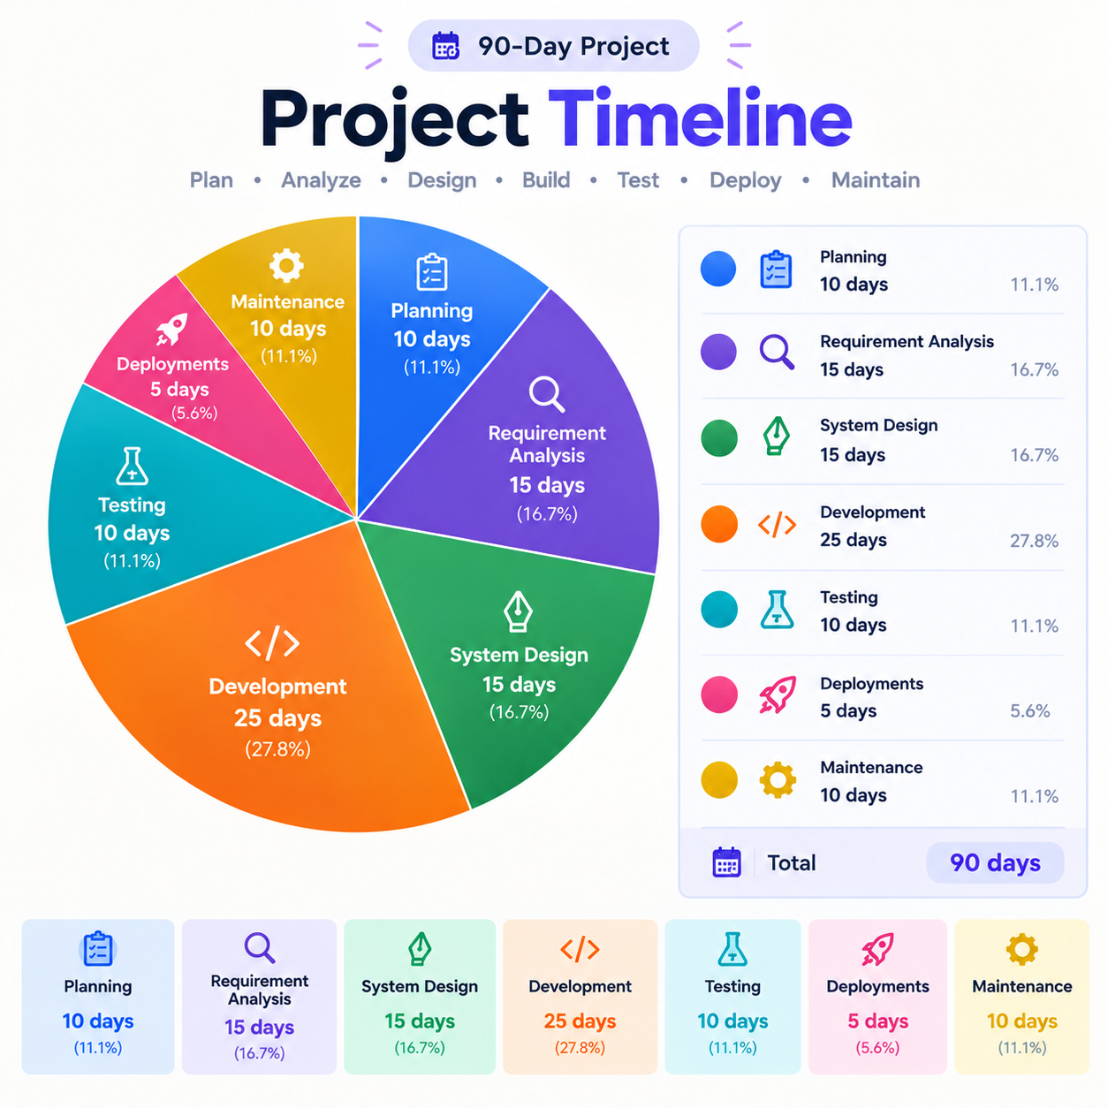

SDLC
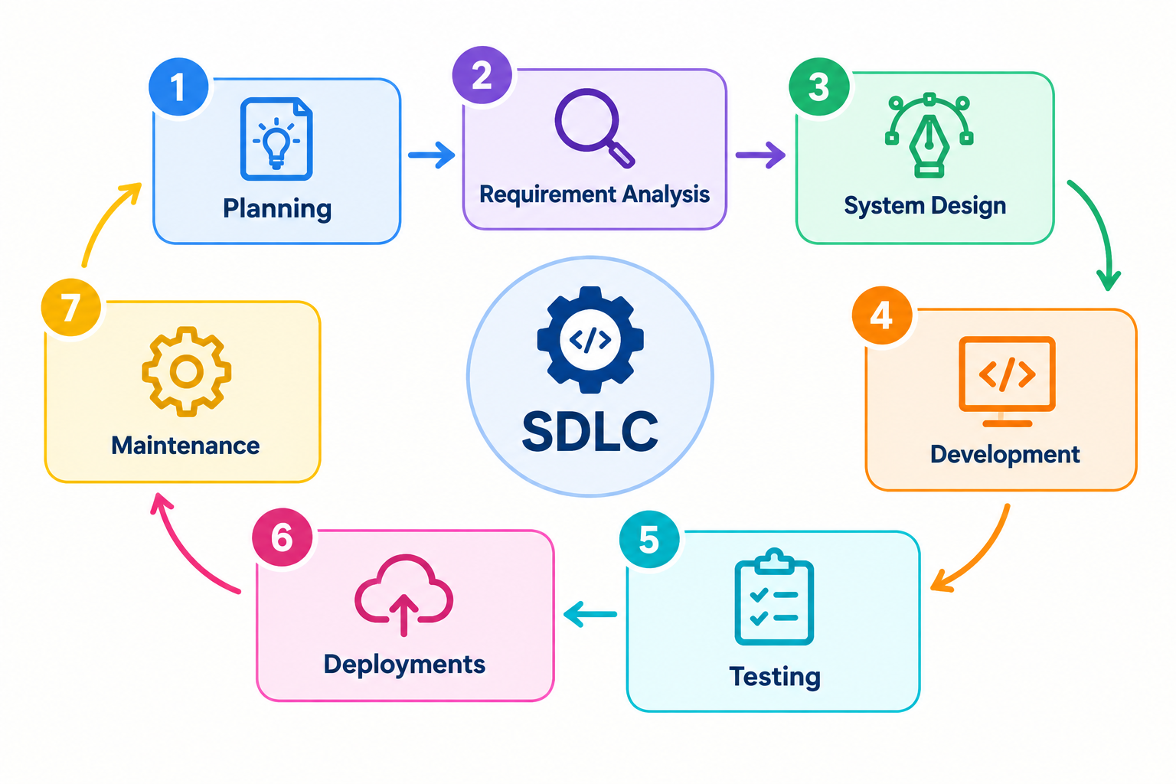
( SOFTWARE DEVELOP MENT LIFE CYCLE )

- PROBLEM DEFINITION
- OBJECTIVE OF PROJECT
- REQUIRMENT SPECIFICATION (QUESTION ANS)
- REQUIREMENT GATHERING

PROBLEM DEFINITION

In the traditional shopping system, customers have to visit physical stores to purchase products. This can be time-consuming and inconvenient, especially for elderly people, busy customers, and people who live far from shopping centers. Customers may also face problems such as crowded stores, long queues, limited shop timings, and difficulty comparing products and prices.

With the development of internet technology, online shopping provides a more convenient solution. Customers can purchase products from their home at any time without visiting a physical store. They can easily browse products, search for required items, check product details, add products to a shopping cart, and place orders online.

The E-Commerce Online Shopping System is developed to provide a simple, convenient, and user-friendly platform for online shopping. The system reduces the need for physical store visits and saves customers' time and effort.

This project uses HTML, CSS, and JavaScript for developing the frontend and Node.js with Express.js for developing the backend. HTML and CSS provide the structure and design of the website, while JavaScript and EJS are used to create dynamic and interactive web pages. Node.js and Express.js handle the backend logic, user requests, product management, and order processing. MongoDB is used to store and manage user, product, cart, and order data.

The main purpose of this system is to make the shopping process faster, easier, more accessible, and convenient for customers.

OBJECTIVE OF PROJECT

The main objective of the E-Commerce Online Shopping System is to develop a simple, efficient, and user-friendly online platform that allows customers to purchase products without visiting a physical store.
The major objectives of the project are:
- To provide customers with an easy and convenient online shopping platform.
- To allow users to browse, search, and view product details online.
- To reduce the time and effort required for traditional shopping.
- To allow customers to add products to a shopping cart and place orders online.
- To provide a user-friendly and responsive interface HTML,CSS,JS,EJS.
- To develop a reliable backend using Node.js and Express.js for managing users, products, and orders.
- To provide customers with shopping access from anywhere and at any time.
- To improve the overall shopping experience through a fast and organized online system.

REQUIRMENT SPECIFICATION (QUESTION ANS)

1. Purpose and Business Model

Q1. What is the purpose of creating (developing) the website/web application, and what is the business model?
The purpose is to develop an online shopping website for a general shopping mall. The business owner wants to sell mall products online so customers can purchase products from home. The website will make product purchasing easier for customers and help increase company sales.

2. Customer Requirements

Q2. What should customers be able to do on the website?
Customers should be able to perform the following activities:
- Register and log in, with password reset functionality.
- View available products.
- Search for products.
- Add products to the shopping cart.
- Place orders.
- Make online payments.
- View orders and order status.
- Give product reviews and ratings.
Q5. Do you want online payment?
Yes. Customers should be able to pay online using UPI, debit card, and credit card.

Q6. Should customers receive order confirmation and track orders?
Yes. Customers should receive order confirmation through SMS and should be able to track their order status.
Q7. Do you want customers to search for products?
Yes. A product search option should be available on the website.
3. Admin Requirements
Q3. What should the Admin be able to do?
The Admin should be able to:
Add, edit, and delete products.
Manage categories and sub-categories.
Manage customers.
View and update orders.
Check payment details.
Generate sales reports.
4. Product Categories and Price Range
Q4. How many product categories and brands are available in the mall, and what are the product price ranges?
There are five main product categories:-
Luxury Watches, Classic Watches, Sports Watches, Chronograph Watches, Limited Edition Watches.
There are five main product categories:-
Rolex ,Omega , Patek Philippe , TAG Heuer , Empario Armani , Tissot,
Rado , Seiko

4.1 Categories
Categories Name | Price (₹)
Luxury Watches | ₹50,000 – ₹10,00,000
Classic Watches | ₹10,000 – ₹2,00,000
Sports Watches | ₹8,000 – ₹1,50,000
Chronograph Watches | ₹15,000 – ₹3,00,000
Limited Edition Watches | ₹75,000 – ₹10,00,000

4.3 Brands
Brands Name | Price (₹)
Rolex | ₹5,00,000 – ₹10,00,000
Omega | ₹3,00,000 – ₹8,00,000
Patek Philippe | ₹7,00,000 – ₹10,00,000
TAG Heuer | ₹1,50,000 – ₹5,00,000
Empario Armani | ₹20,000 – ₹80,000
Tissot | ₹25,000 – ₹1,00,000
Rado | ₹80,000 – ₹3,00,000
Seiko | ₹15,000 – ₹1,50,000

5. Design Requirements
Q8. Do you have any design preferences? Should the design be responsive?
The website should have a simple, attractive, responsive, and mobile-friendly design.
6. Project Schedule and Expected Traffic
Q9. What is the expected project completion time?
The expected project completion time is 3 to 4 months.
Q10. How many users/traffic do you expect?
Approximately 5,000 to 7,000 users are expected.
7. Security Requirements
Q11. What security features are required?
The website requires secure login, user registration, and JWT-based authentication/security.
8. Functional Requirements
Q12. What are the functional requirements?
The main functional requirements of the system are:
User registration and login
Product management
Category management
Shopping cart
Online payment
Order management
Order tracking
Customer management
Sales reports
Product search
Payment detail checking
Sales report generation
9. Non-Functional Requirements
Q13. What are the non-functional requirements?
The main non-functional requirements are:
The website should be easy to use.
The login system should be secure.
Payment details should be handled securely.
The system should be able to generate sales reports.
10. Technology Requirements
Q17. What programming technologies will be used to develop the website?
The proposed technologies are:
Layer | Technology
Frontend | HTML, CSS,EJS,Bootstrap,JS
Backend | Node.js, Express.js
Communication | API
Database | MongoDb Atlast

